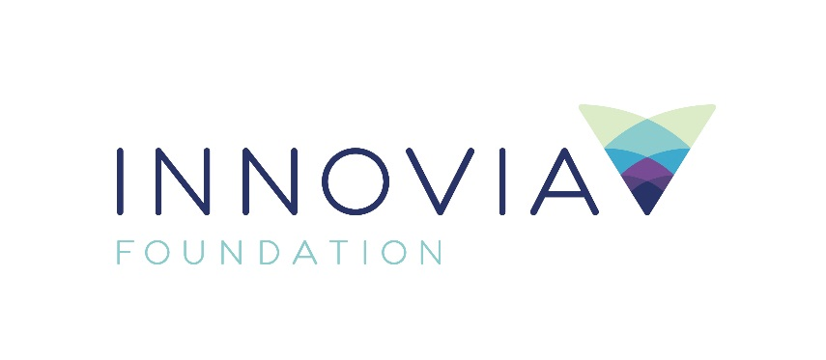
Innovia Foundation
421 W. Riverside Ave., Suite 606
Spokane, WA 99201-0402
www.innovia.org
Contact: Molly Sanchez,
Grants and Community Engagement
509-624-2606; msanchez@innovia.org

FOR IMMEDIATE RELEASE

Innovia Foundation and Premera Social Impact
invest $65,000 in Nonprofit Capacity Building

SPOKANE, WA, 10/20/2020 - Innovia Foundation and Premera Social Impact announce a $65,000 investment for capacity building in partnership with the national resource organization Network for Good to 13 regional nonprofit organizations. The Network for Good Jumpstart Program offers virtual coaching to create a financial resiliency strategy for nonprofits. This year’s cohort of participants was selected in part because of their programmatic focus on serving communities of color, rural communities, people impacted by health disparities and other historically marginalized groups.

“Now, more than ever, philanthropy must invest in organizations serving those who have been historically marginalized and underserved, ensuring they have the resources needed to reduce inequities and create thriving communities,” said Innovia Foundation CEO Shelly O’Quinn. “With the Premera Social Impact partnership, we will be able to more than double our investment in local nonprofits that are working so hard to address critical needs throughout our region.”

“As a healthcare leader, we must address the inequity that exists for many of the communities we serve,” said David Condon, Vice President of Eastern Washington, Premera. “We are proud to partner with Innovia to invest in these programs that are among the leaders in removing barriers for those disproportionally impacted by their race or geography. They, like us, are working toward a healthier community.”

In 2018, Innovia Foundation invested a total of $29,480 for Jumpstart grants to 11 organizations in Eastern Washington and North Idaho, which returned more than $302,000 in nonprofit impact.

In this second round, Innovia Foundation and Premera Social Impact will provide 13 organizations with grant funding for an immersive, yearlong capacity building program that pairs nonprofit leaders with a personal fundraising coach to expand efficacy in acquiring, retaining and upgrading individual donors. The program also includes technology tools and technical assistance designed to help execute strategies to fundraise more effectively during and beyond the pandemic.

The nonprofit organizations participating in the Jumpstart program are:

American Indian Community Center | Spokane County, WA
The Arc of Spokane | Spokane County, WA
Carl Maxey Center | Spokane County, WA
Excelsior | Spokane County, WA
Feast Collective | Spokane County, WA
Friends of Stonerose Fossils | Ferry County, WA
Gizmo-CDA, Inc. | Kootenai County, ID
Heritage Health | Kootenai County, ID
Latinos en Spokane | Spokane County, WA
MiA – Mujeres in Action | Spokane County, WA
Refugee Connections Spokane | Spokane County, WA
Rural Resources Community Action | Stevens County, WA
Sandpoint Community Resource Center | Bonner County, ID

###

Innovia Foundation ignites generosity that transforms lives and communities so that every person has the opportunity to thrive. As the community foundation for Eastern Washington and North Idaho, we partner with people who want to make our world better. We work together to address and solve our region’s problems, help those in need, identify and respond to our greatest opportunities and leave a lasting impact. Each year, Innovia Foundation invests nearly $7 million into our communities through grants and scholarships to nonprofit organizations and local students.

