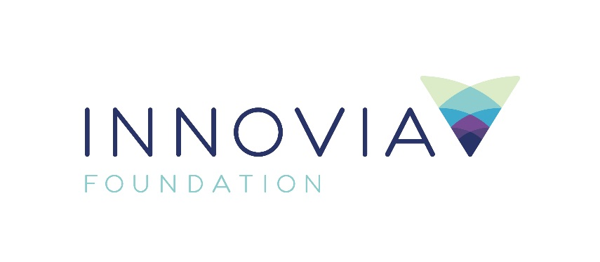
Innovia Foundation
421 W. Riverside Ave., Suite 606
Spokane, WA 99201-0402
www.innovia.org
Contact: Sarah Bain
509-951-0627; sbain@innovia.org

FOR IMMEDIATE RELEASE

Fundraising Begins to Rebuild First Four Homes in Malden
Western Anabaptist Mission Service Volunteers Commit Labor to Build Four Homes
SPOKANE, WA, 12/10/2020 — Innovia Foundation, the community foundation for Eastern Washington and North Idaho, is announcing a campaign to raise $300,000 to rebuild four of the homes lost during the devastating September wildfires that destroyed the communities of Malden and Pine City.
The Western Anabaptist Mission Service in St. Ignatius, Montana is volunteering their labor to rebuild four homes lost in the fire. The Mission service, whose vision is to “reach out to people in need and be the hands for Jesus in today’s world,” has helped communities in Montana, Idaho and Washington rebuild from wildfires over the past several years, including the Carlton Complex Fire in Okanogan County.
“This is an incredible opportunity and will provide much-needed encouragement for the families,” said Scott Hokonson, Recovery Operations Director. “While we know it will take several years to rebuild, seeing new life begin to rise out of the ashes will foster hope throughout the Pine Creek region.”
Construction materials for each home will cost around $75,000. Volunteers can begin building in January once money has been raised. Volunteers will build a new home every three to four weeks.
“It will take a village to rebuild the communities of Malden and Pine City,” said Shelly O’Quinn, CEO, Innovia Foundation. “No matter the size of the donation, it will be through the generosity of individuals, churches and businesses across our state and region that every family displaced by the devastating wildfires can once again have a place to call home.”
Last week, our region responded with incredible generosity and adopted Malden and Pine City families to bring a bit of holiday cheer by providing Christmas dinner and presents for families who lost everything.
On September 7, the Babb Fire swept across Whitman County. An estimated 80% of homes in Malden and nearly 75% of homes in Pine City were lost. Approximately two-thirds of these families did not have insurance because their homes were deemed uninsurable. The Pine Creek area is the most economically depressed area in the county.
Innovia Foundation will work with the Long Term Recovery Committee and nonprofit housing partners to develop a zero interest loan program and assist families with the application process.
For more information and to donate to the Pine Creek Fund, please visit www.innovia.org or call (509) 624-2606.

###

Innovia Foundation ignites generosity that transforms lives and communities so that every person has the opportunity to thrive. As the community foundation for Eastern Washington and North Idaho, we partner with people who want to make our world better. We work together to address and solve our region’s problems, help those in need, identify and respond to our greatest opportunities and leave a lasting impact. Each year, Innovia Foundation invests nearly $7 million into our communities through grants to nonprofit organizations and scholarships to students.

