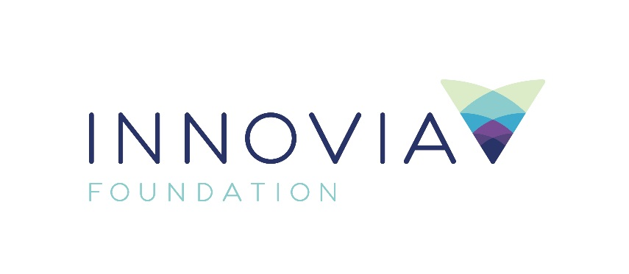
Innovia Foundation
421 W. Riverside Ave., Suite 606
Spokane, WA 99201-0402
www.innovia.org
Contact: Aaron McMurray,
Chief Strategy Officer
509-624-2606; amcmurray@innovia.org

FOR IMMEDIATE RELEASE

Innovia Foundation Announces Generous Matching Challenge for Racial Equity Reporter and Launch of Fund to Advance Racial Equity in Eastern Washington and North Idaho

SPOKANE, WA, 12/10/2020 - Innovia Foundation announced two initiatives to advance racial equity and dismantle systemic racism in Eastern Washington and North Idaho.

A generous $50,000 matching gift challenge was issued through the Michael Conley Charitable Fund at Innovia Foundation to hire a race relations and racial equity reporter position. The challenge was matched and exceeded with a generous $60,000 commitment from the Smith-Barbieri Progressive Fund, a charitable foundation that focuses on building human potential, fostering nonprofit creativity and ingenuity, helping marginalized people build their power and other quality of life issues in the Inland Northwest.

The position will raise awareness on the important issues around racial equity and systemic racism in our community, providing coverage for both the Spokesman Review and the Black Lens.

“We’re honored to answer Mr. Conley’s call for this important collaboration to add a reporter at the Spokesman-Review dedicated to the issues most affecting Black, Indigenous and People of Color in our region,” said Sharon Smith, Co-Trustee of the Smith-Barbieri Progressive Fund. "It’s a primary goal of the Progressive Fund to help tear down barriers of people and groups often left behind by the burdens of inequity so they can achieve the power necessary to thrive. Education of all people on these important issues is a step in that process.”

Additionally, Innovia Foundation has created a Racial Equity Grantmaking Fund for Eastern Washington and North Idaho, to support the vital work of organizations addressing racial injustice, structural inequity, and economic disparity. The fund is seeded with a donation of $100,000 from the Ballmer Group. Initial distributions will be directed to mitigating the impacts of Covid-19 among communities of color in Eastern Washington.

“The matching challenge for the Racial Equity reporter, and the Racial Equity Grantmaking Fund provide tangible ways for generous individuals, families and organizations to join us in the important work of advancing racial equity throughout our region,” said Innovia Foundation CEO Shelly O’Quinn. “The reporter position will give voice and raise awareness on the important issues around racial equity, while the grantmaking fund provides an opportunity to put that voice into action by funding solutions.”

The Racial Equity Fund will be comprised of two parts; funds that will be made available for current grants to support organizations and projects throughout the region working to eliminate systemic racism and injustice and enhance opportunities for building more inclusive communities. Additionally, an endowed portion of the fund will generate sustainable funding to advance the work of racial equity in our region for generations to come. Contributions to the fund will be split 50/50 between current year grantmaking and the endowed portion.

“Now, more than ever, philanthropy must invest in organizations serving those who have been historically marginalized and underserved, ensuring they have the resources to fulfill their highest potential,” said Betsy Wilkerson, Spokane City Council Member, and a member of Innovia Foundation’s Board of Directors. “This is important work, and I am proud of Innovia for making a commitment, not just to the urgent, immediate needs of communities of color, but the long-term work of eliminating systemic racism and disparities to ensure that every person in our region has the opportunity to thrive.”

Funded through the Community Journalism and Civic Engagement Fund at Innovia, the Racial Equity Reporter position will be named in honor of Mr. Carl Maxey, influential civil rights leader and the first prominent Black attorney in Spokane.

“This is a significant opportunity for our community, and I’m excited to partner with the Spokesman Review to bring greater awareness to the long-standing issues that have faced the black community, and other communities of color,” said Sandra Williams, founder and editor of the Black Lens.

Contributions to the Carl Maxey Racial Equity Reporter position, or the Racial Equity Grantmaking Fund, can be made at www.innovia.org/racialequity, or by sending contributions to 421 W. Riverside Ave. Suite 606, Spokane, WA 99201.

###

Innovia Foundation ignites generosity that transforms lives and communities so that every person has the opportunity to thrive. As the community foundation for Eastern Washington and North Idaho, we partner with people who want to make our world better. We work together to address and solve our region’s problems, help those in need, identify and respond to our greatest opportunities and leave a lasting impact. Each year, Innovia Foundation invests nearly $7 million into our communities through grants and scholarships to nonprofit organizations and local students.

