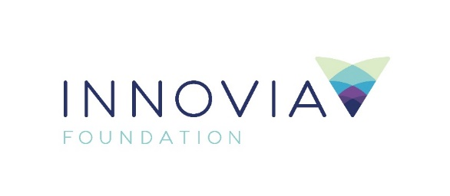
Innovia Foundation
421 W. Riverside Ave., Suite 606
Spokane, WA 99201-0402
www.innovia.org
Contact: Molly Sanchez, Director of Grants and Community Engagement
msanchez@innovia.org or 509-808-5504

FOR IMMEDIATE RELEASE
Community Grants and Arts & Culture Grants Programs Accepting
Applications through January 22
SPOKANE, WA, December 15, 2020 — Innovia Foundation is currently accepting applications through its Community Grants and Arts & Culture Grants programs to organizations impacted by COVID-19 and summer wildfires. These two grant programs are open through January 22. Grant recipients will be announced by March 17.
The Community Grants program will prioritize funding requests that mitigate the impacts of COVID-19 and/or summer wildfires, offer collaborative and innovative solutions, and enhance economic vitality, especially for organizations addressing disproportionately impacted communities.
The Arts and Culture Recovery Fund will provide flexible funding to organizations adversely impacted by the outbreak of COVID-19, with priority given to those that have a history of fueling local economy, as well as helping organizations adapt programming to be delivered in a socially distanced manner.
“We know nonprofits throughout this region are struggling on a daily basis to navigate the challenges presented by the COVID-19 pandemic. Innovia Foundation continues to make intentional changes to our traditional grant practices to be responsive to community needs and opportunities,” said CEO Shelly O’Quinn.
Previous changes include increased funding for COVID-19 relief; reduced reporting requirements and other restrictions on existing grants; awarded general operating grants; and actively engaged with communities hardest hit by COVID-19. Following this grant round, Innovia will re-assess guidelines and timeline for future grant cycles.
Funding is available for nonprofit organizations serving communities in Innovia’s 20-county service area of Eastern Washington and North Idaho. Grant awards will be made in the following impact areas: arts and culture, education and youth development, quality of life, health and well-being and economic vitality. A full overview of the grants and application guidelines can be found at Innovia’s website: innovia.org/nonprofits/apply-for-a-grant. For questions about these grant programs, please contact Molly Sanchez at msanchez@innovia.org.

###
Innovia Foundation ignites generosity that transforms lives and communities so that every person has the opportunity to thrive. As the community foundation for Eastern Washington and North Idaho, we partner with people who want to make our world better. We work together to address and solve our region’s problems, help those in need, identify and respond to our greatest opportunities and leave a lasting impact. Each year, Innovia Foundation invests nearly $7 million into our communities through grants to nonprofit organizations and scholarships to local students.

