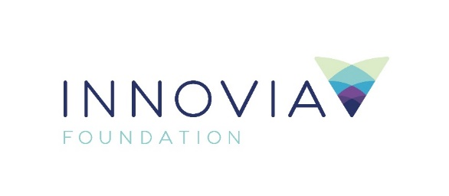
Innovia Foundation
421 W. Riverside Ave., Suite 606
Spokane, WA 99201-0402
www.innovia.org
Contact: Sarah Bain, Marketing and Communications
sbain@innovia.org or 509-951-0627

FOR IMMEDIATE RELEASE
$25,000 Grant Supports Coworking Space in Deer Park
SPOKANE, WA, January 26, 2021—Innovia Foundation announces a $25,000 grant to the Deer Park Chamber of Commerce to help support The Hotspot at Deer Park, a coworking space which opened in November 2020. This grant is made possible with funding from Washington Trust Bank to assist with COVID-19 business recovery efforts.
The Chamber of Commerce created this space to provide individuals and groups with an affordable workspace, high-speed internet, print services and other amenities to help promote new business ventures. The remodeled facility offers broadband connectivity in response to the need for remote workers to find a safe place to work.
“Innovia Foundation is honored to contribute to the economic vitality of the region, especially during this unprecedented time of recovery from the impact of COVID-19,” said Innovia Foundation CEO Shelly O’Quinn. “It is vitally important for our region’s dedicated workers to have safe spaces in which to operate, and the Hotspot is a perfect example of providing an environment conducive to efficiency.”
“As part of our ongoing commitment to supporting a strong local economy and our more immediate focus on community revitalization through the pandemic, Washington Trust Bank is pleased to fund this endeavor and take active steps in enabling our local workforce and the small business community,” said Jack Heath, president of Washington Trust Bank. “This co-working space is an investment in the future of our community that will provide individuals and small businesses with the resources necessary to promote productivity and remove the infrastructure barriers of entry for fledgling enterprises.”
This new coworking space is open to the public and offers drop-in services, as well as the ability for small business owners to reserve a workstation. The growing need for access to the internet and the expansion of entrepreneurial opportunities makes this a perfect investment for Innovia Foundation and Washington Trust Bank. The Hotspot team has also added additional measures to keep the space cleaned and sanitized so that it is safe for everyone.
For more information about The Hotspot, please reach out to the Deer Park Chamber of Commerce, 509-276-5900 or visit their website deerparkchamber.com.
###
Innovia Foundation ignites generosity that transforms lives and communities so that every person has the opportunity to thrive. As the community foundation for Eastern Washington and North Idaho, we partner with people who want to make our world better. We work together to address and solve our region’s problems, help those in need, identify and respond to our greatest opportunities and leave a lasting impact. Each year, Innovia Foundation invests nearly $7 million into our communities through grants to nonprofit organizations and scholarships to local students.

