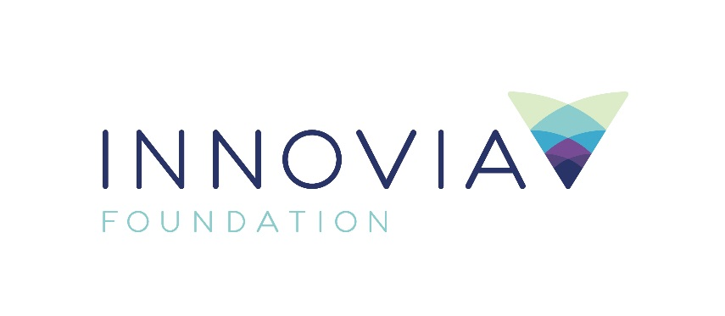
Innovia Foundation
421 W. Riverside Ave., Suite 606
Spokane, WA 99201-0402
www.innovia.org
Contact: Molly Sanchez, Director of Grants & Community Engagement
509-624-2606; msanchez@innovia.org

FOR IMMEDIATE RELEASE

Innovia Foundation launches Wildfire Emergency Response Fund - Eastern Washington to address immediate and long-term needs of communities
SPOKANE, WA, September 18, 2020; Innovia Foundation has established the Wildfire Emergency Response Fund - Eastern Washington to provide emergency relief to nonprofit organizations and businesses supporting communities, individuals and families adversely impacted by the 2020 wildfire season.

The fund is seeded with a generous $150,000 gift from an anonymous corporation and a $10,000 contribution from the Disaster Relief Fund at Innovia Foundation.

“The Wildfire Emergency Response Fund will support short-term emergency response and long-term resiliency efforts for those negatively impacted by these devastating fires,” said Innovia Foundation CEO Shelly O’Quinn.

Since the beginning of September, wildfires have burned over 300,000 acres in Washington. On September 7, two rural communities in Whitman County faced the destructive Babb Fire. An estimated 80% of the homes in Malden (population 200) and nearly 75% of the homes in Pine City (population 50) were destroyed. Early estimates show that 2/3 of families did not have home insurance because their homes were deemed uninsurable.

“As a region, we are always better when we come together,” said O’Quinn. “We invite generous individuals to join us in supporting recovery efforts in communities like Malden and Pine City by donating to the relief fund.”

Donations to the Wildfire Emergency Response Fund - Eastern Washington can be made by visiting www.innovia.org/wildfire-relief or by mailing a check payable to Innovia Foundation with Wildfire Emergency Response Fund in the memo. Checks should be mailed to Innovia Foundation, 421. W. Riverside Ave., Suite 606, Spokane WA 99201.

Funds raised will help enhance and support the organizations working locally to rebuild communities devastated by recent wildfires.

In addition to establishing the Wildfire Relief Fund, Innovia Foundation is working in partnership with local communities and key organizations to ensure coordinated grantmaking and is a member of a community task force focused on long term solutions for communities impacted by wildfires.

Innovia would like to recognize the many organizations providing critical infrastructure and support to Malden and Pine City, including:

- Greater Inland Northwest Red Cross Chapter;
- Rosalia Community Center/Lion’s Club
- Community Baptist Church, Rosalia
- Harvest Assembly of God Church, Rosalia
- Rosalia Gifted Grannies
- United Way of Whitman County
- The Veteran’s Center
- Avista Corporation

###

Innovia Foundation ignites generosity that transforms lives and communities so that every person has the opportunity to thrive. As the community foundation for Eastern Washington and North Idaho, we partner with people who want to make our world better. We work together to address and solve our region’s problems, help those in need, identify and respond to our greatest opportunities and leave a lasting impact. Each year, Innovia Foundation invests nearly $7 million into our communities through grants and scholarships to nonprofit organizations and local students.

