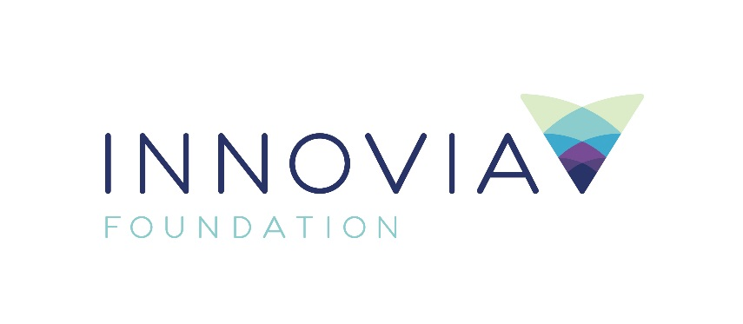
Innovia Foundation
421 W. Riverside Ave., Suite 606
Spokane, WA 99201-0402
www.innovia.org
Contact: Aaron McMurray, Chief Strategy Officer
509-624-2606; amcmurray@innovia.org

FOR IMMEDIATE RELEASE

Innovia Foundation Photography Contest 2021 Winners
SPOKANE, WA, July 29, 2021 — Innovia Foundation is thrilled to announce the winners of the second annual photography contest focusing on the theme of “Reimagining Our Communities.” This year has seen many challenges for everyone with the global pandemic. However, one benefit has been making us appreciate the small moments, and here at Innovia, we wanted to showcase some of those moments and let everyone share in the beauty around us. There were so many amazing submissions that our esteemed review committee had a tough time selecting the winners, but they selected frontrunners for first, second, and third place in each category and one winner overall. Photographers submitted photos under the categories of:
- Landscape and Nature
- Capturing the Human Spirit
- Places and Spaces
- Animals or Wildlife
- The Heart of Community
- Nonprofit Mission in Action
The photos had to be within the Foundation’s 20-county service region including Eastern Washington and Northern Idaho. The overall winner is Joanie Christian with her photo titled, “All Tuckered Out” of a mother loon and her babies in Ferry Country. A sweet and rare sighting because loons only ride on their mother’s back for one week of their lives and only nest in a handful of lakes in our region.

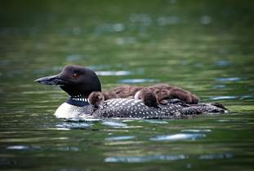

In the Landscape and Nature category, first and second place went to Joanie Christian with “All Tuckered Out” and “Palouse Vista” and third place went to Dan Komen with “Winter Scene.”

In the Capturing the Human Spirit category, first place went to Dan Wilson with “Mountain Junkies at Dusk on Beacon Hill,” second place went to Lisa Giegel with “The View from The Barn,” and third place went to Vanette Leighty with “Grit.”

In the Places and Space category, first place went to Joanie Christian with “This is the Life,” second place went to Dan Komen with “Pend Oreille Valley Spring,” and third place went to Judi Cronin with “Golden Palouse and Barn.”

In the Animals or Wildlife category, first place went to Deb Hunsicker with “Scotchman Peak Sentinel,” second place went to Mary Sanderson with “Hummer Sips,” and third place went to Joanie Christian with “Quail in a Tamarack of Autumn Gold.”

In The Heart of the Community category, first place went to Joanie Christian with “Heart of the City in Blue Hour,” second place went to Dave Williams with “Hands Across the Falls - United,” and third place to Suzanne Bjork with “Music Around the World.”

In the last category of Nonprofit Mission in Action, first and second place went to Caroline Schibel with “A Child Hopes for Home,” and “Empowered Women, Empower Communities,” and third place went to Arrianne Maldonado with “ECEAP - Early Learning in Action.”

Congratulations to all our contestants and winners! First place winners get to select a nonprofit of their choice to receive a $200 grant and the overall winner gets to select a nonprofit to receive a $1,000 grant. However, the real winners are the community and nonprofits that are so deserving of the grants. Our first-place winners all selected amazing organizations to benefit from the grants.
- #1 Place Winner for Animals & Wildlife, Deb Hunsicker, selected:
  - Friends of Scotchman Peaks Wilderness
- #1 Place Winner for Capturing Human Spirit, Dan Wilson, selected:
  - The East Chapter of the Evergreen Mountain Bike Alliance
- #1 Place Winner for Nonprofit Mission in Action, Caroline Schibel, selected:
  - Habitat For Humanity
- #1 Place Winner for Landscape & Nature, Places & Spaces, Heart of the Community & the overall prize, Joanie Christian, selected:
  - Friends of the Little Pend Oreille National Wildlife Refuge, Bird of Prey Northwest, Biodiversity Research Institute & Fire District #9 (LPO Lake Chain)

We look forward to sharing the contest again next year and seeing the wonderful photos people take of our region.

###
Innovia Foundation ignites generosity that transforms lives and communities so that every person has the opportunity to thrive. As the community foundation for Eastern Washington and North Idaho, we partner with people who want to make our world better. We work together to address and solve our region’s problems, help those in need, identify and respond to our greatest opportunities and leave a lasting impact. Each year, Innovia Foundation invests nearly $7 million into our communities through grants and scholarships to nonprofit organizations and local students.

